SIMATS ENGINEERING
JAVA PROGRAMMING – LAB PROGRAM - 2
NAME : U SUBIKSHA
REG NO : 192424135

Q1 — Employee Performance & Payroll Dashboard

CODE :
import java.awt.*;
import java.awt.event.*;
public class EmployeePayroll extends Frame implements ActionListener
{
Label l1, l2, l3, l4, l5, l6, l7;
TextField id, name, salary, days;
Choice department, designation;
Choice rating;
Button generate, reset;
TextArea report;
EmployeePayroll()
{
setTitle("Employee Performance & Payroll Dashboard");
setSize(650, 600);
setLayout(new FlowLayout());
l1 = new Label("Employee ID:");
id = new TextField(20);

l2 = new Label("Employee Name:");
name = new TextField(20);
l3 = new Label("Department:");
department = new Choice();
department.add("AI & DS");
department.add("CSE");
department.add("ECE");
department.add("IT");
l4 = new Label("Designation:");
designation = new Choice();
designation.add("Developer");
designation.add("Tester");
designation.add("Manager");
designation.add("Analyst");
l5 = new Label("Basic Salary:");
salary = new TextField(20);
l6 = new Label("Working Days:");
days = new TextField(20);
l7 = new Label("Performance Rating:");
rating = new Choice();
rating.add("1");
rating.add("2");
rating.add("3");
rating.add("4");
rating.add("5");

generate = new Button("Generate Report");
reset = new Button("Reset");
report = new TextArea(12, 50);

add(l1);
add(id);
add(l2);
add(name);
add(l3);
add(department);
add(l4);
add(designation);
add(l5);
add(salary);
add(l6);
add(days);
add(l7);
add(rating);
add(generate);
add(reset);
add(report);
generate.addActionListener(this);
reset.addActionListener(this);
setVisible(true);
}

public void actionPerformed(ActionEvent e)
{
if(e.getSource() == generate)
{
try
{
double basic = Double.parseDouble(salary.getText());
int workingDays = Integer.parseInt(days.getText());
int performance = Integer.parseInt(rating.getSelectedItem());
double gross = basic + (basic * 0.10);
double bonus = 0;
if(performance >= 4)
{
bonus = basic * 0.20;
}
else if(performance == 3)
{
bonus = basic * 0.10;
}
double net = gross + bonus;
report.setText("");
report.append("----- EMPLOYEE PAYROLL REPORT -----\n\n");
report.append("Employee ID: " + id.getText() + "\n");
report.append("Employee Name: " + name.getText() + "\n");
report.append("Department: " +
department.getSelectedItem() + "\n");
report.append("Designation: " +
designation.getSelectedItem() + "\n");
report.append("Basic Salary: " + basic + "\n");
report.append("Working Days: " + workingDays + "\n");
report.append("Performance Rating: " + performance + "\n");
report.append("Gross Salary: " + gross + "\n");
report.append("Performance Bonus: " + bonus + "\n");
report.append("Net Salary: " + net + "\n");
}
catch(Exception ex)
{
report.setText("Please enter valid salary and working days.");
}
}

if(e.getSource() == reset)
{
id.setText("");
name.setText("");
salary.setText("");
days.setText("");
report.setText("");
}
}

public static void main(String args[])
{
new EmployeePayroll();
}
}
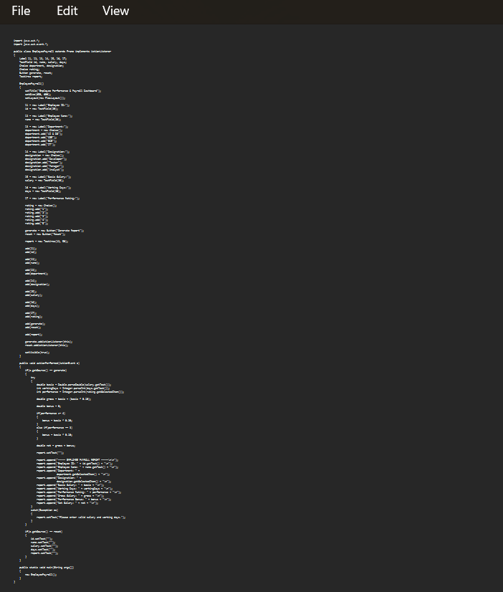
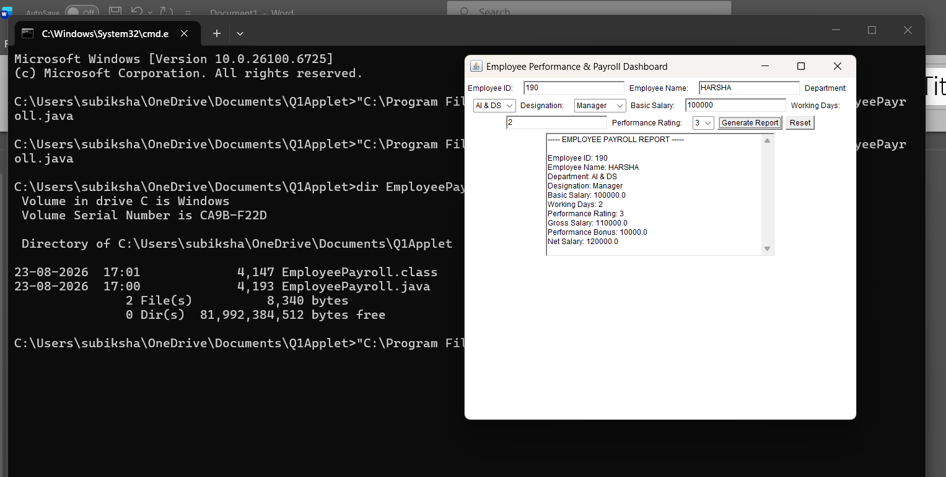

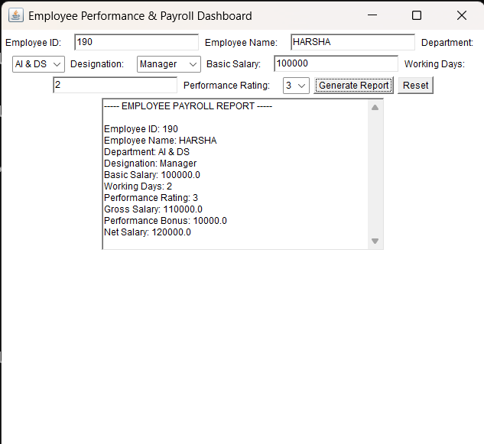

2. Online Food Ordering & Billing System

OUTPUT
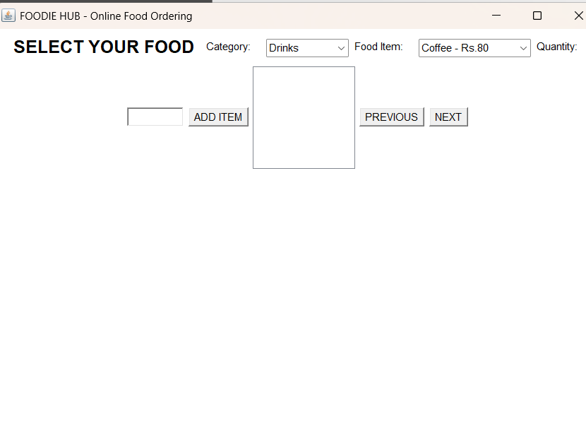
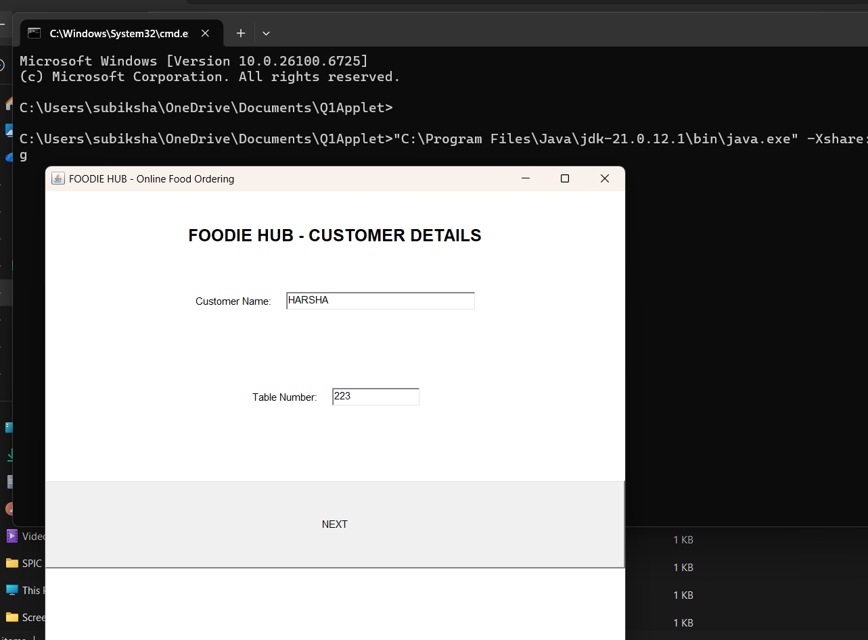

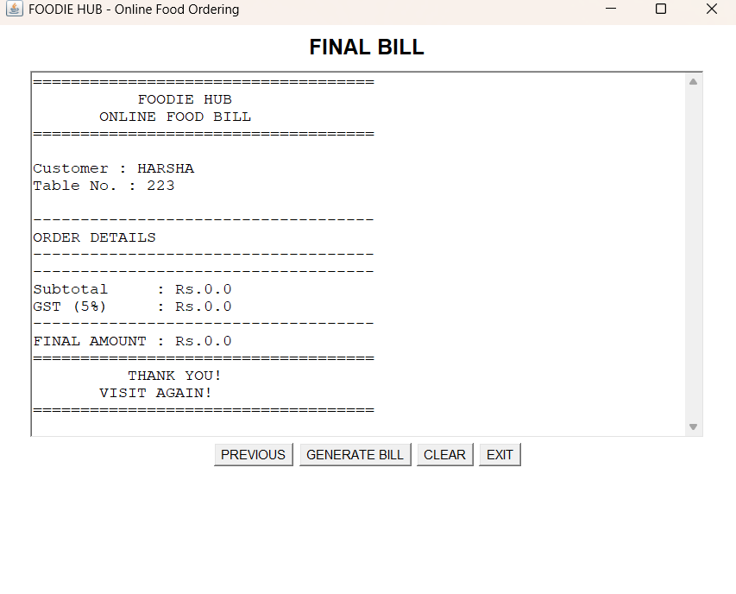

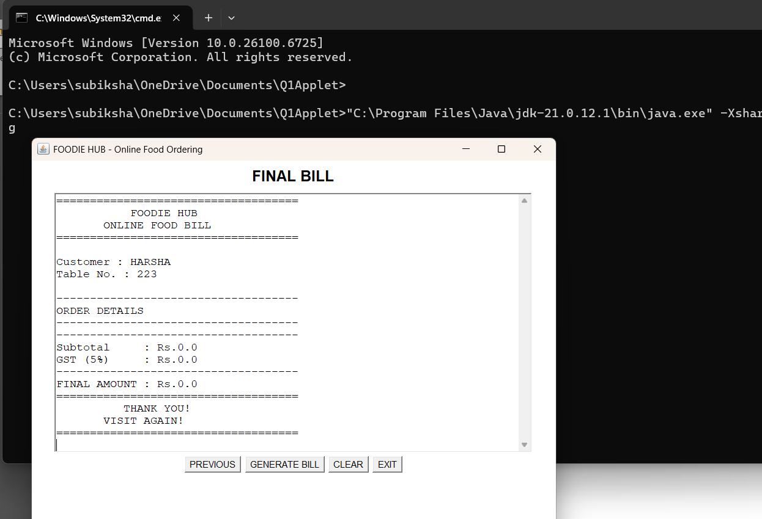

CODE :
import java.awt.*;
import java.awt.event.*;

public class FoodOrdering extends Frame implements ActionListener
{
CardLayout card;
Panel cards;

TextField customerName, tableNo, quantity;
Choice category, food;

List orderList;
TextArea bill;

Button next1, next2;
Button previous1, previous2;
Button addItem, generateBill, clear, exit;

double subtotal = 0;

FoodOrdering()
{
setTitle("FOODIE HUB - Online Food Ordering");
setSize(700, 600);

card = new CardLayout();
cards = new Panel(card);

/* CUSTOMER DETAILS */

Panel customerPanel = new Panel();
customerPanel.setLayout(new GridLayout(5, 1, 10, 10));

Label title1 = new Label(
"FOODIE HUB - CUSTOMER DETAILS",
Label.CENTER);

title1.setFont(new Font("Arial", Font.BOLD, 20));

Panel p1 = new Panel();
p1.add(new Label("Customer Name:"));

customerName = new TextField(25);
p1.add(customerName);

Panel p2 = new Panel();
p2.add(new Label("Table Number:"));

tableNo = new TextField(10);
p2.add(tableNo);

next1 = new Button("NEXT");

customerPanel.add(title1);
customerPanel.add(p1);
customerPanel.add(p2);
customerPanel.add(next1);

cards.add(customerPanel, "Customer");

/* FOOD SELECTION */

Panel foodPanel = new Panel();
foodPanel.setLayout(new FlowLayout());

Label title2 = new Label(
"SELECT YOUR FOOD",
Label.CENTER);

title2.setFont(new Font("Arial", Font.BOLD, 20));

foodPanel.add(title2);

foodPanel.add(new Label("Category:"));

category = new Choice();
category.add("Main Course");
category.add("Snacks");
category.add("Drinks");

foodPanel.add(category);

foodPanel.add(new Label("Food Item:"));

food = new Choice();

food.add("Pizza - Rs.200");
food.add("Burger - Rs.120");
food.add("Biryani - Rs.180");
food.add("Sandwich - Rs.100");
food.add("Coffee - Rs.80");

foodPanel.add(food);

foodPanel.add(new Label("Quantity:"));

quantity = new TextField(5);
foodPanel.add(quantity);

addItem = new Button("ADD ITEM");
foodPanel.add(addItem);

orderList = new List(8);
foodPanel.add(orderList);

previous1 = new Button("PREVIOUS");
next2 = new Button("NEXT");

foodPanel.add(previous1);
foodPanel.add(next2);

cards.add(foodPanel, "Food");

/* BILL */

Panel billPanel = new Panel();
billPanel.setLayout(new FlowLayout());

Label title3 = new Label(
"FINAL BILL",
Label.CENTER);

title3.setFont(new Font("Arial", Font.BOLD, 20));

billPanel.add(title3);

bill = new TextArea(20, 55);
bill.setFont(
new Font("Monospaced", Font.PLAIN, 14));

billPanel.add(bill);

previous2 = new Button("PREVIOUS");
generateBill = new Button("GENERATE BILL");
clear = new Button("CLEAR");
exit = new Button("EXIT");

billPanel.add(previous2);
billPanel.add(generateBill);
billPanel.add(clear);
billPanel.add(exit);

cards.add(billPanel, "Bill");

/* EVENT HANDLING */

next1.addActionListener(this);
next2.addActionListener(this);

previous1.addActionListener(this);
previous2.addActionListener(this);

addItem.addActionListener(this);
generateBill.addActionListener(this);
clear.addActionListener(this);
exit.addActionListener(this);

add(cards, BorderLayout.CENTER);

setVisible(true);
}

public void actionPerformed(ActionEvent e)
{
if(e.getSource() == next1)
{
if(customerName.getText().equals("") ||
tableNo.getText().equals(""))
{
bill.setText(
"Please enter Customer Name and Table Number.");
}
else
{
card.show(cards, "Food");
}
}

else if(e.getSource() == addItem)
{
try
{
int qty =
Integer.parseInt(quantity.getText());

if(qty <= 0)
return;

String item = food.getSelectedItem();

double price = 0;

if(item.startsWith("Pizza"))
price = 200;

else if(item.startsWith("Burger"))
price = 120;

else if(item.startsWith("Biryani"))
price = 180;

else if(item.startsWith("Sandwich"))
price = 100;

else if(item.startsWith("Coffee"))
price = 80;

double cost = price * qty;

subtotal = subtotal + cost;

orderList.add(
item +
" Qty: " + qty +
" Cost: Rs." + cost);

quantity.setText("");
}
catch(Exception ex)
{
quantity.setText("");
}
}

else if(e.getSource() == next2)
{
card.show(cards, "Bill");
}

else if(e.getSource() == previous1)
{
card.show(cards, "Customer");
}

else if(e.getSource() == previous2)
{
card.show(cards, "Food");
}

else if(e.getSource() == generateBill)
{
double gst = subtotal * 0.05;
double total = subtotal + gst;

bill.setText("");

bill.append(
"====================================\n");

bill.append(
" FOODIE HUB\n");

bill.append(
" ONLINE FOOD BILL\n");

bill.append(
"====================================\n\n");

bill.append(
"Customer : " +
customerName.getText() + "\n");

bill.append(
"Table No. : " +
tableNo.getText() + "\n\n");

bill.append(
"------------------------------------\n");

bill.append("ORDER DETAILS\n");

bill.append(
"------------------------------------\n");

for(int i = 0;
i < orderList.getItemCount();
i++)
{
bill.append(
orderList.getItem(i) + "\n");
}

bill.append(
"------------------------------------\n");

bill.append(
"Subtotal : Rs." +
subtotal + "\n");

bill.append(
"GST (5%) : Rs." +
gst + "\n");

bill.append(
"------------------------------------\n");

bill.append(
"FINAL AMOUNT : Rs." +
total + "\n");

bill.append(
"====================================\n");

bill.append(
" THANK YOU!\n");

bill.append(
" VISIT AGAIN!\n");

bill.append(
"====================================\n");
}

else if(e.getSource() == clear)
{
customerName.setText("");
tableNo.setText("");
quantity.setText("");

orderList.removeAll();

bill.setText("");
subtotal = 0;
card.show(cards, "Customer");
}
else if(e.getSource() == exit)
{
System.exit(0);
}
}
public static void main(String args[])
{
new FoodOrdering();
}
}

